**Exploitation using nmap and Metasploit**

In this lab exam I used nmap and Metasploit to identify the vulnerability present in the gtarget system and exploited that system password file.

Target ip -192.168.68.129

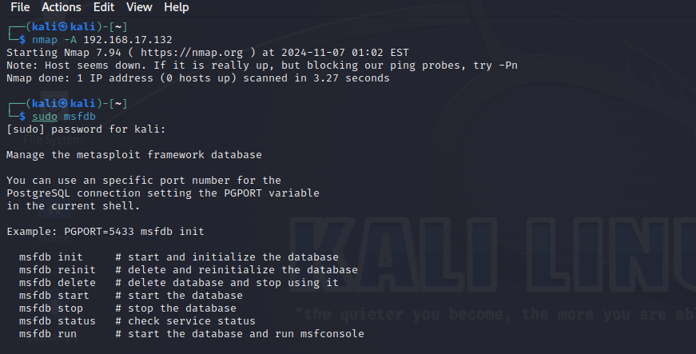

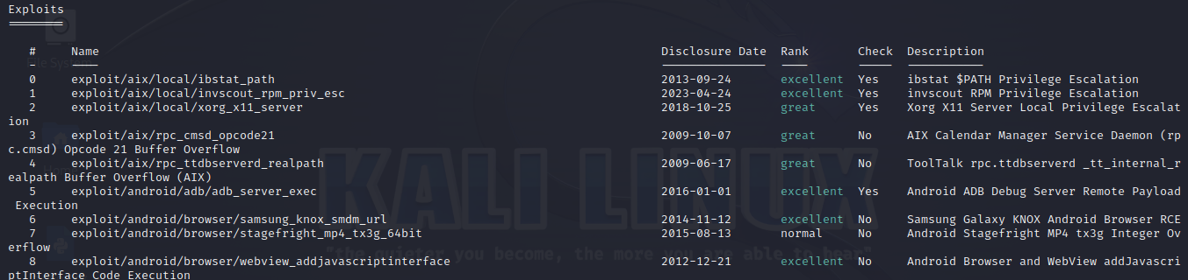

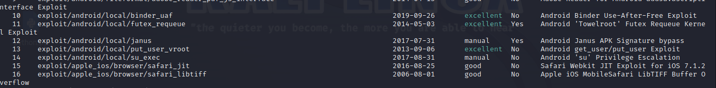

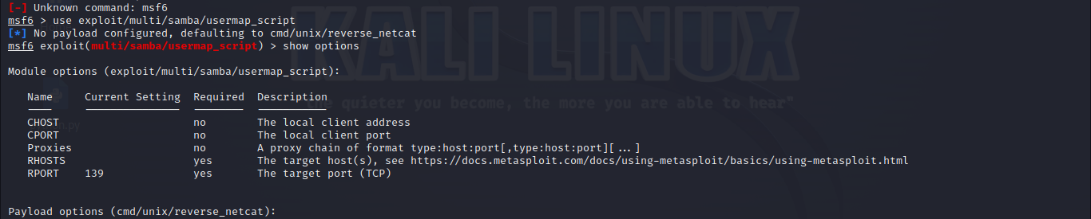

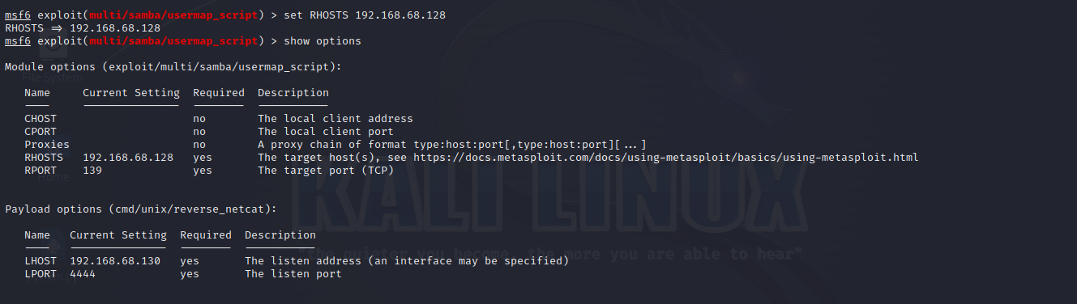

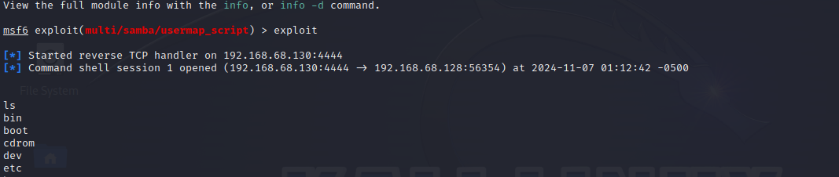

AS we can see here the password file ie /etc/password file is extracted from the target system that is sensitive information



